**How to Upload Artifact to Nexus using Jenkins**

**What is Artifactory in DevOps ?**

In CI/CD process when we build our project we obtain an artifactory after a build.So further in deployment phase we deploy these artifactories on our production / pre-production server.

So now if we assume what if we don’t use artifacts…It will be really very difficult over time.hat is why Artifacts are important to hold onto throughout the development process and also after that.

**What is Nexus Repository Manager ?**

**Artifact Repository:** Artifact repository is a location where you can store your all artifacts which are needed for the projects.

**Nexus Repository Manager**: It allows developer to collect, retrieve, manage our artifacts.

Basically Nexus Repository Manager helps us to host our repositories.

For eg- “Maven Central Repository” so we can use it to retrieve all dependencies needed for a Maven build.

**Prerequisites**

* Java Projects – You can use our Sample[Java GitHub Repo](https://github.com/devopshint/java-app-with-maven)
* Jenkins Installed with Maven Job – Follow our article to [setup Jenkins on Linux](https://www.fosstechnix.com/install-jenkins-on-ubuntu/)
* Nexus Repository Manager Installed with Credentials – Follow this this article to [setup Nexus on Linux](https://www.fosstechnix.com/how-to-install-nexus-repository-on-ubuntu/)

Navigate to **Dashboard->> Manage Jenkins ->> Manage Plugin** ->> Search for **“GitHub Integration Plugin”**, **“Maven Integration Plugin”** and “**Nexus Artifactory Uploader**“.

**#1:Create Maven Job in Jenkins**

Enter Job name and select **“Maven Project”** and **Click OK.**

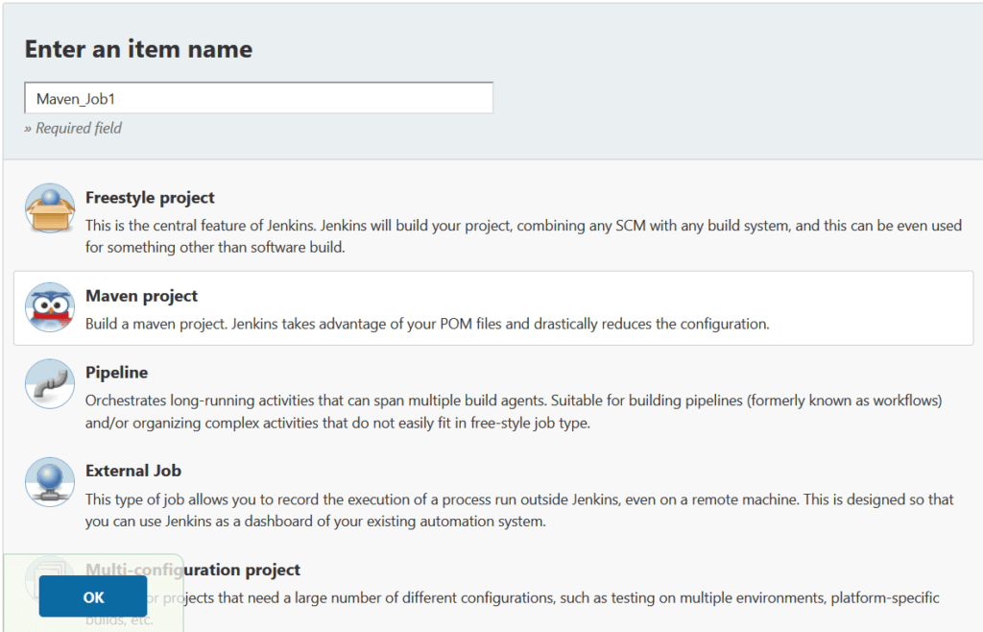

**#2:Enter Project Details in Jenkins (source code management)**

Give some description for your Project., Now In **Source Code Management** provide your Git Repository URL or you can use [our GitHub Repository](https://github.com/devopshint/java-app-with-maven) for testing.

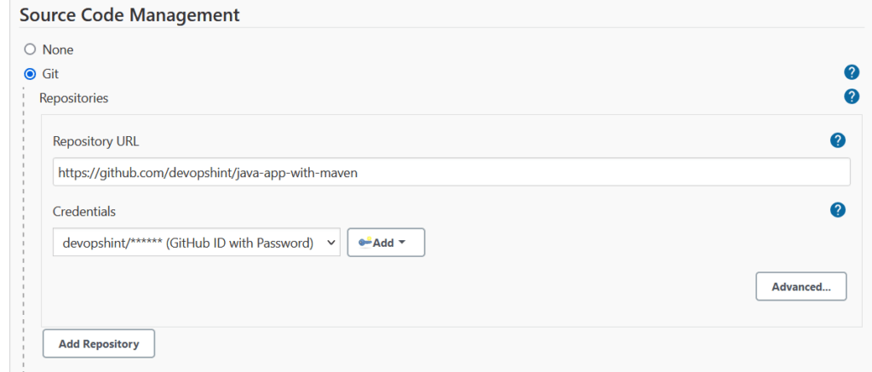

**#3:Set Branch and Build Triggers in Jenkins**

Provide your particular github branch.

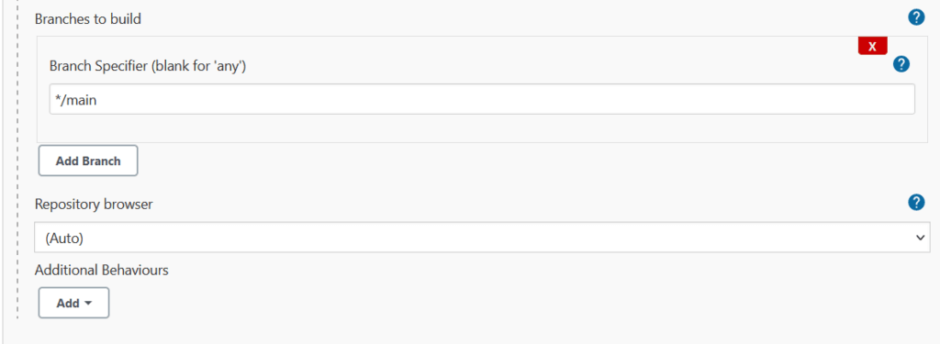

**#4:Provide POM file for Maven Project in Jenkins**

Now the most important part of our build is POM file, So in build section provide path of your projects pom file, Set **clean**and **package** as Goals and options.

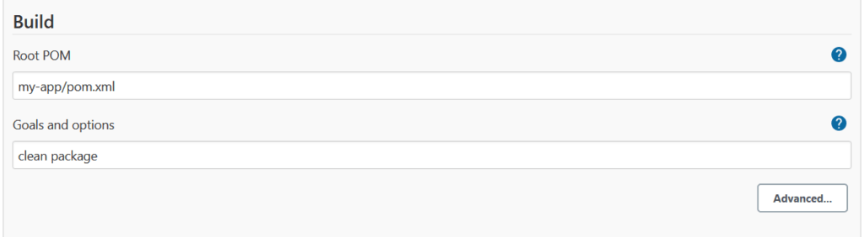

**#5:Upload Artifact to Nexus using Jenkins**

Select Nexus artifact uploader in post build action, Enter Nexus Repository Manager details

Nexus Version: **NEXUS3**

Protocol: **HTTP/HTTPS**

Nexus URL: **Nexus_Server_IP:8081**

Credentials: **add the nexus user credentials to upload the artifacts**

GroupId: **${POM_GROUPID}**

Version: **${POM_VERSION}**

Repository: **maven-snapshots**

ArtifactId: **${POM_ARTIFACTID}**

Type: **${POM_PACKAGING}**

File target/: **${POM_ARTIFACTID}-${POM_VERSION}.${POM_PACKAGING}**

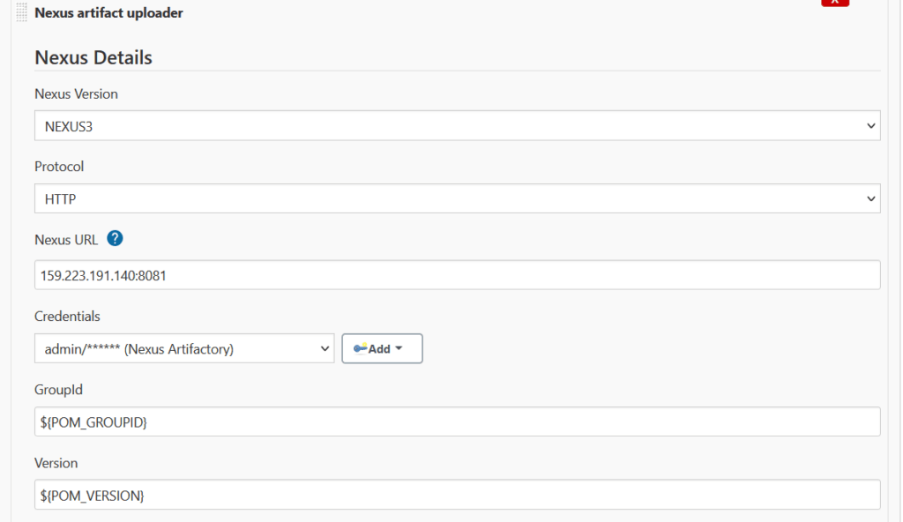

Enter the Java Project Artifact details

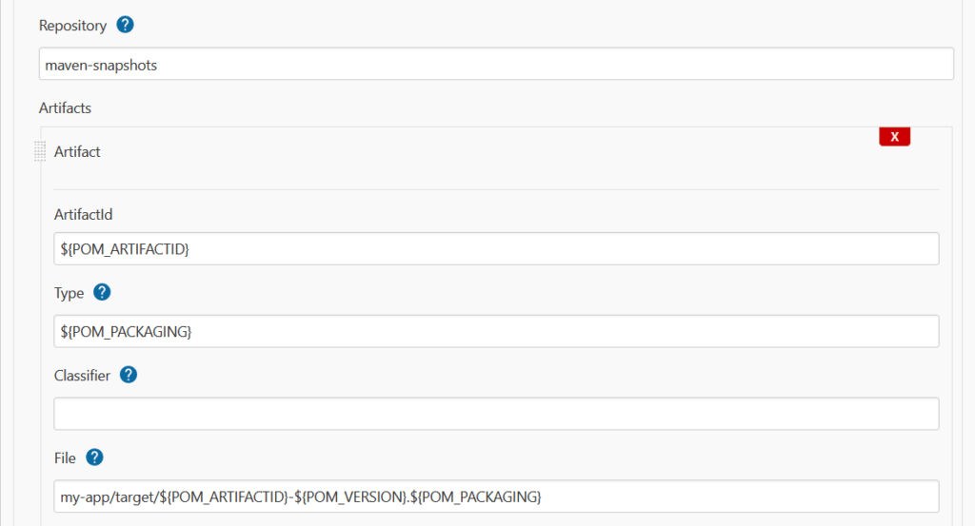

Values of above you can take from from pom.xml file.

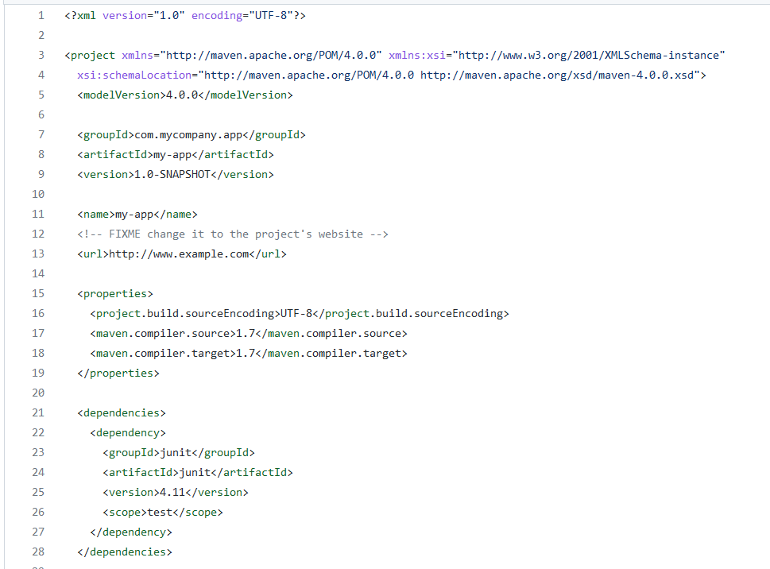

Save and apply the build, Click on **Build Now**, you can see console output, artifact is uploaded to nexus.

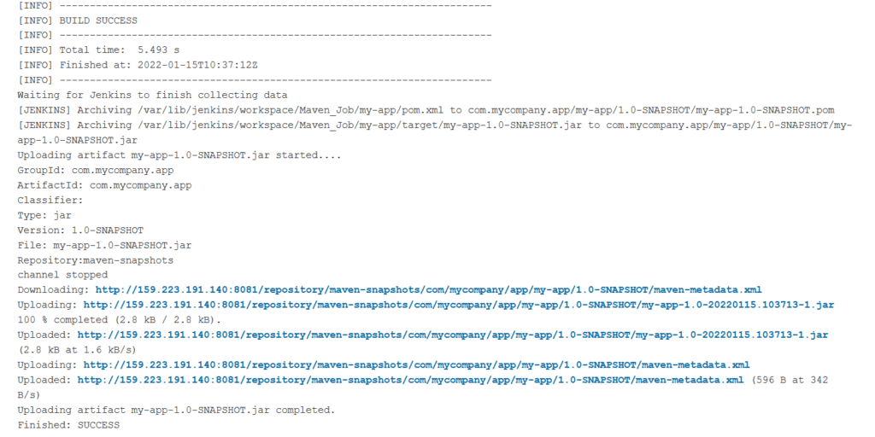

**#6:Artifact uploaded to Nexus**

Login to Nexus, you can see Java artifact is uploaded to Nexus Repository Manager.

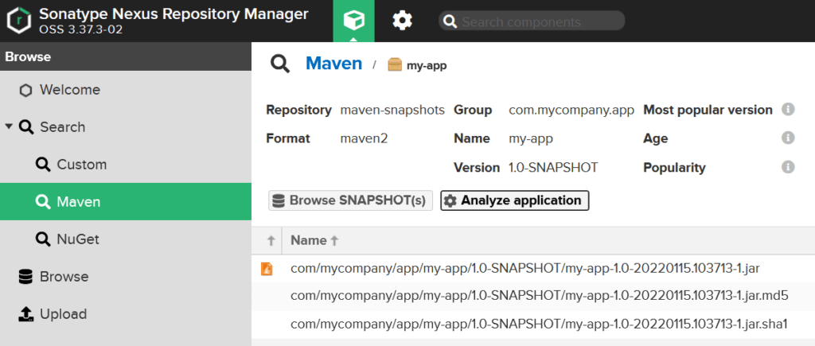

**Conclusion:**

In this article we have covered How to Upload Artifact to Nexus using Jenkins.

(OR)

**Workflow Automation: Publishing Artifacts to Nexus Repository using Jenkins Pipelines**

In this guide, we will use Jenkins as a Continuous Integration server and [Nexus Repository](https://www.sonatype.com/nexus-repository-oss) as a build repository.

The goal of this guide is to create a workflow where we can build, store, organize, and monitor the compiled artifacts by Maven through our CI server.

Before we begin, make sure that you already have Jenkins up and running. In case you haven’t set up Jenkins yet, then copy the below command and run it on your Docker enabled host/machine.

$ docker run -d --name jenkins-ci -p 8080:8080 jenkins/jenkins:lts

Once the Jenkins container is configured on your local/remote machine, go to your preferred browser and open the URL:

http:///your-ip-addr:8080

On the very first page, Jenkins will ask you for the admin password, which you can find by running below mentioned command in your terminal:

$ docker exec -i jenkins-ci cat /var/jenkins_home/secrets/initialAdminPassword  
  
b5102c8d9fa245dbb0b8da03f504d3a5

Follow the guided steps to finish the configuration. Save the username and password securely for future use.

**Installing Nexus Repository**

Nexus is a repository manager that allows you to store and retrieve artifacts. It enables you to host your built artifacts in a private and secure repo. *[****Editor's Note:***[*Free Nexus Repository training is available here*](https://learn.sonatype.com/)*.]*

You can always pull the Nexus Docker image using the following command:

$ docker pull sonatype/nexus3  
   
Using default tag: latest  
latest: Pulling from sonatype/nexus3  
cb3c77f9bdd8: Pull complete   
fd8daf2668d1: Pull complete   
fd1ff82b00e8: Pull complete   
2a05f7b573af: Pull complete   
Digest: sha256:6570855dfbc3eb094fe5cbbacec87aa8b91d16394dab627177e1deeebb5ac8ee  
Status: Downloaded newer image for sonatype/nexus3:latest  
docker.io/sonatype/nexus3:latest

Now it’s time to run downloaded sonatype/nexus on the default port 8081. Follow these commands:

$ docker run -d --name nexus_repo -p 8081:8081 sonatype/nexus3

Usually it takes 1 to 2 minutes for the Nexus service to launch in your newly created Docker container. If you wish to follow the log to see if Nexus is up and ready, then run the following command:

$ docker logs nexus_repo -f

In logs you will see a message stating Started Sonatype Nexus OSS 3.20.1-01  
This means your Nexus Repository Manager is ready to use. Now go to your browser and open

http://your-ip-addr:8081

Find the *Sign In* option as shown below:

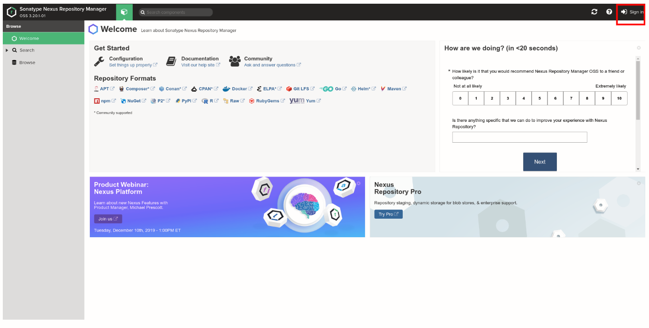

The default username is admin, whereas to retrieve the password you need to run the following command:

$ docker exec -i nexus_repo cat /nexus-data/admin.password  
502ace93-5450-4f0d-97d2-9b3b3a88d149

And that’s it. Your Nexus Repository Manager is ready to use. The next step is to create a new repository.

**Create a Repository in Nexus**

In this step, you are going to create a Maven Hosted repository in Nexus, where your Jenkins is going to upload “build” artifacts.

**Step 1:**  
Follow the below-mentioned steps to create a hosted repository, name it  maven-nexus-repo, which you are going to use throughout this guide.

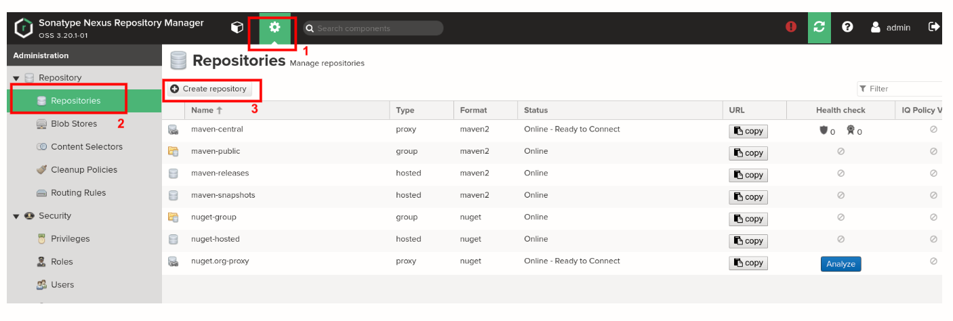

Select *maven2 (hosted)* recipe from the list as shown below:

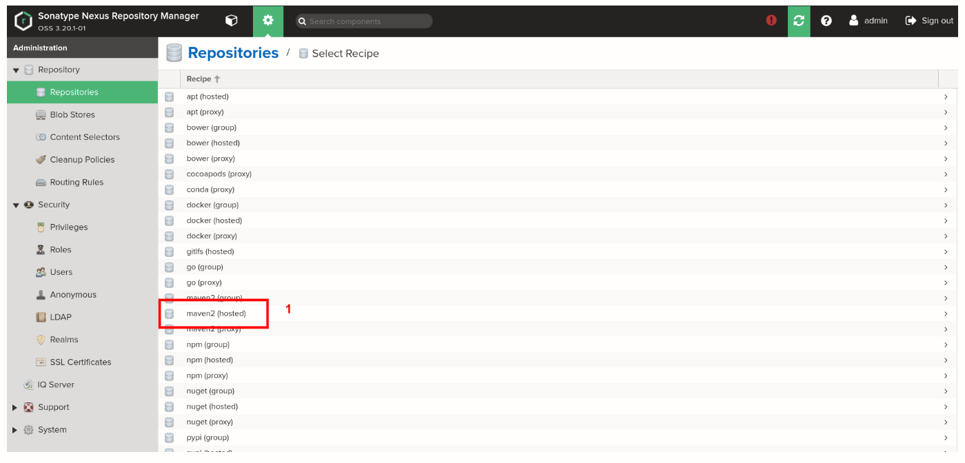

**Step 2:**  
On the *Create Repository* page

* Enter the name as *maven-nexus-repo*
* In Version Policy, select the *Mixed* type of artifacts.
* Under the *Hosted* section, in *Deployment policy*, select *Allow redeploy*.  It will allow you to deploy an application multiple times.

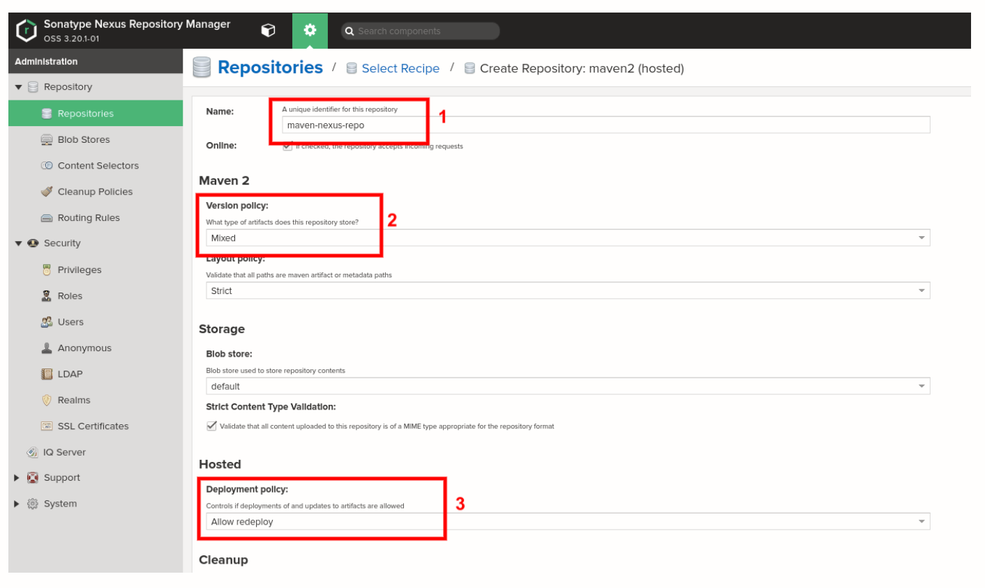

**Step 3:**  
To create a new user, go to *Dashboard > Server Administrator and Configuration > User > Create user*. Select *Local* user type which happens to be the default Realm:

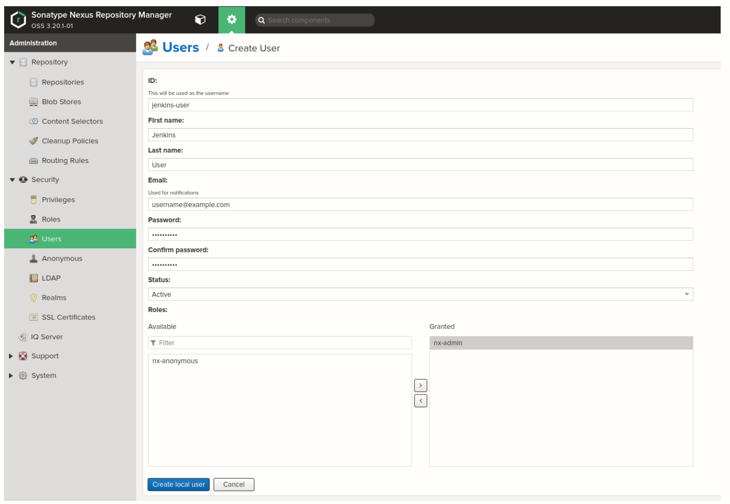

In the *Create User* page

1. **ID**: Enter the desired ID; in our case, it is jenkins-user.
2. **First Name**: Enter the desired first name; in our case, it is Jenkins.
3. **Last Name**: Enter the desired second name; in our case, it is User.
4. **Email**: Enter your email address.
5. **Status**: Select *Active* from your drop-down menu.
6. **Roles**: Make sure that you grant the *nx-admin* role to your user.

If you want more user creation details, [click here](https://help.sonatype.com/repomanager3/security/users?ref=hackernoon.com).

With this, we are through with the setup part of Nexus Repository Manager. Let us move to Jenkins to setup Nexus there.

**Install and Configure Nexus Plugins in Jenkins**

Here you are going to install and configure a few plugins for Nexus in Jenkins. For this, go to Jenkins and then *Dashboard > Manage Jenkins > Manage Plugins > Available* and search and install [Nexus Artifact Uploader](https://plugins.jenkins.io/nexus-artifact-uploader?ref=hackernoon.com) and [Pipeline Utility Steps](https://plugins.jenkins.io/pipeline-utility-steps?ref=hackernoon.com).

Add Nexus Repository Manager’s user credentials in Jenkins.

Go to *Dashboard > Credentials > System > Global credentials (unrestricted)*, as shown below:

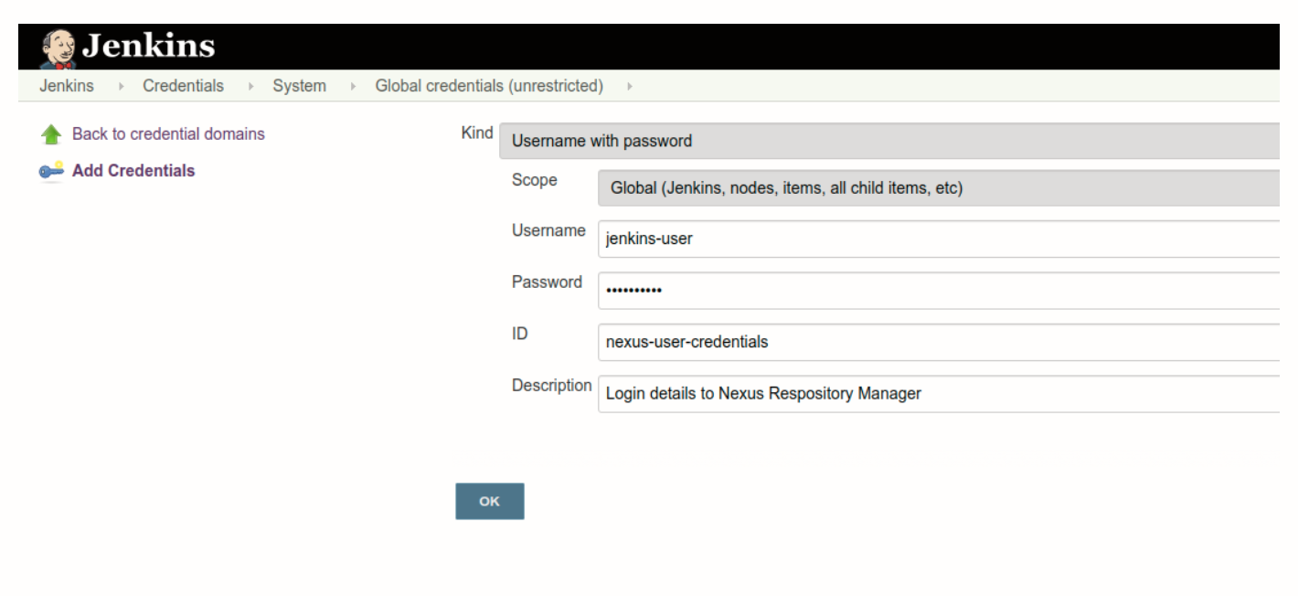

Next, set up Maven as a managed tool. Go to *Dashboard > Manage Jenkins > Global Tool Configuration* and find *Maven*. Under this section, click on the *Maven Installations* button and add *Maven*, as shown below:

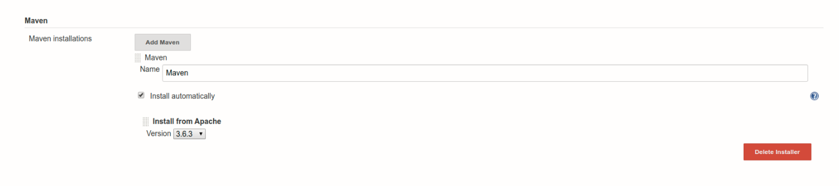

Alternatively, you can also install the Maven binary directly to your container on the /var/jenkins_home directory.

**Create a Jenkins Pipeline**

It’s time to create a Jenkins Job. Here you are going to use Pipeline job type, named as *JenkinsNexus*, as shown below:

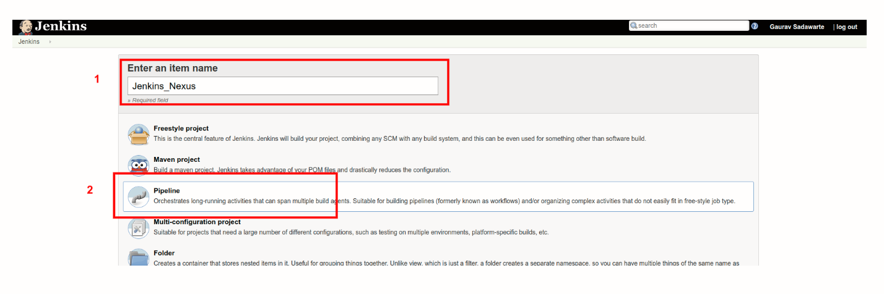

In the next page, find the Pipeline section and copy the below-mentioned script in the text area:

pipeline {  
 agent {  
 label "master"  
 }  
 tools {  
 maven "Maven"  
 }  
 environment {  
 NEXUS_VERSION = "nexus3"  
 NEXUS_PROTOCOL = "http"  
 NEXUS_URL = "you-ip-addr-here:8081"  
 NEXUS_REPOSITORY = "maven-nexus-repo"  
 NEXUS_CREDENTIAL_ID = "nexus-user-credentials"  
 }  
 stages {  
 stage("Clone code from VCS") {  
 steps {  
 script {  
 git 'https://github.com/javaee/cargotracker.git';  
 }  
 }  
 }  
 stage("Maven Build") {  
 steps {  
 script {  
 sh "mvn package -DskipTests=true"  
 }  
 }  
 }  
 stage("Publish to Nexus Repository Manager") {  
 steps {  
 script {  
 pom = readMavenPom file: "pom.xml";  
 filesByGlob = findFiles(glob: "target/*.${pom.packaging}");  
 echo "${filesByGlob[0].name} ${filesByGlob[0].path} ${filesByGlob[0].directory} ${filesByGlob[0].length} ${filesByGlob[0].lastModified}"  
 artifactPath = filesByGlob[0].path;  
 artifactExists = fileExists artifactPath;  
 if(artifactExists) {  
 echo "*** File: ${artifactPath}, group: ${pom.groupId}, packaging: ${pom.packaging}, version ${pom.version}";  
 nexusArtifactUploader(  
 nexusVersion: NEXUS_VERSION,  
 protocol: NEXUS_PROTOCOL,  
 nexusUrl: NEXUS_URL,  
 groupId: pom.groupId,  
 version: pom.version,  
 repository: NEXUS_REPOSITORY,  
 credentialsId: NEXUS_CREDENTIAL_ID,  
 artifacts: [  
 [artifactId: pom.artifactId,  
 classifier: '',  
 file: artifactPath,  
 type: pom.packaging],  
 [artifactId: pom.artifactId,  
 classifier: '',  
 file: "pom.xml",  
 type: "pom"]  
 ]  
 );  
 } else {  
 error "*** File: ${artifactPath}, could not be found";  
 }  
 }  
 }  
 }  
 }  
}

Let’s break down the above-mentioned parameters bit by bit:

* **NEXUS_VERSION**: Here, we have to mention the exact version of Nexus, which can be nexus2or nexus3 . In our case, it is latest version of nexus3 .
* **NEXUS_PROTOCOL**: For this guide we have used HTTP protocol, although, in case of production, you will have to use HTTPS.
* **NEXUS_URL**: Add your IP address and port number, where you are running Nexus. Make sure that you add Nexus instance details without mentioning protocols, i.e., https or http .
* **NEXUS_CREDENTIAL_ID**: Enter the user ID, which you previously created in Jenkins, which in our case is  nexus-user-credentials .
* **Project Git**: Under stages, we used https://github.com/javaee/cargotracker

As you are through with the Pipeline set up, it’s time to Build our project. Go to the *JenkinsNexus* project job page and click *Build Now*. As this is your first build, it is going to take some time, so sit tight.

Once build is a success, in your Jenkins Console Output, you will see something like this:

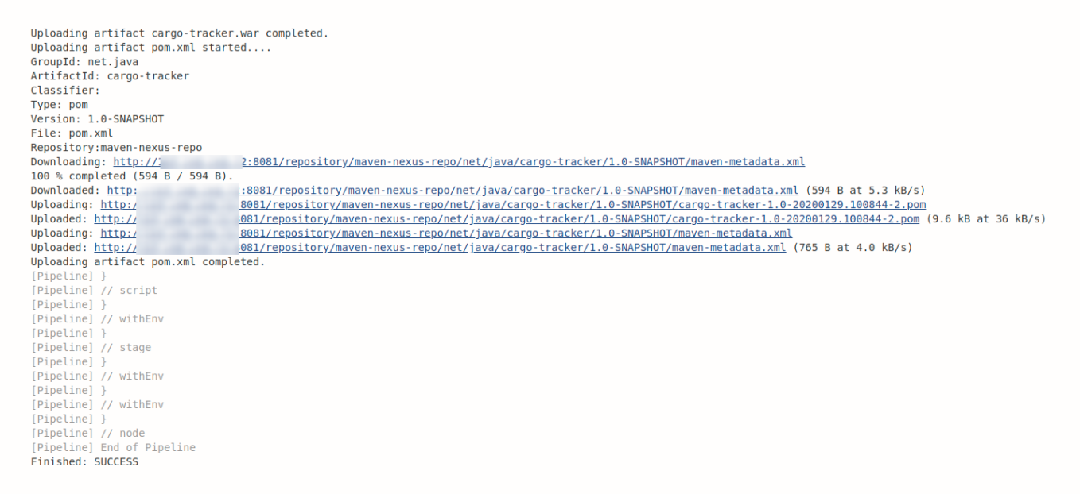

Whereas, in your Nexus Repository Manager, you would see something similar to this:

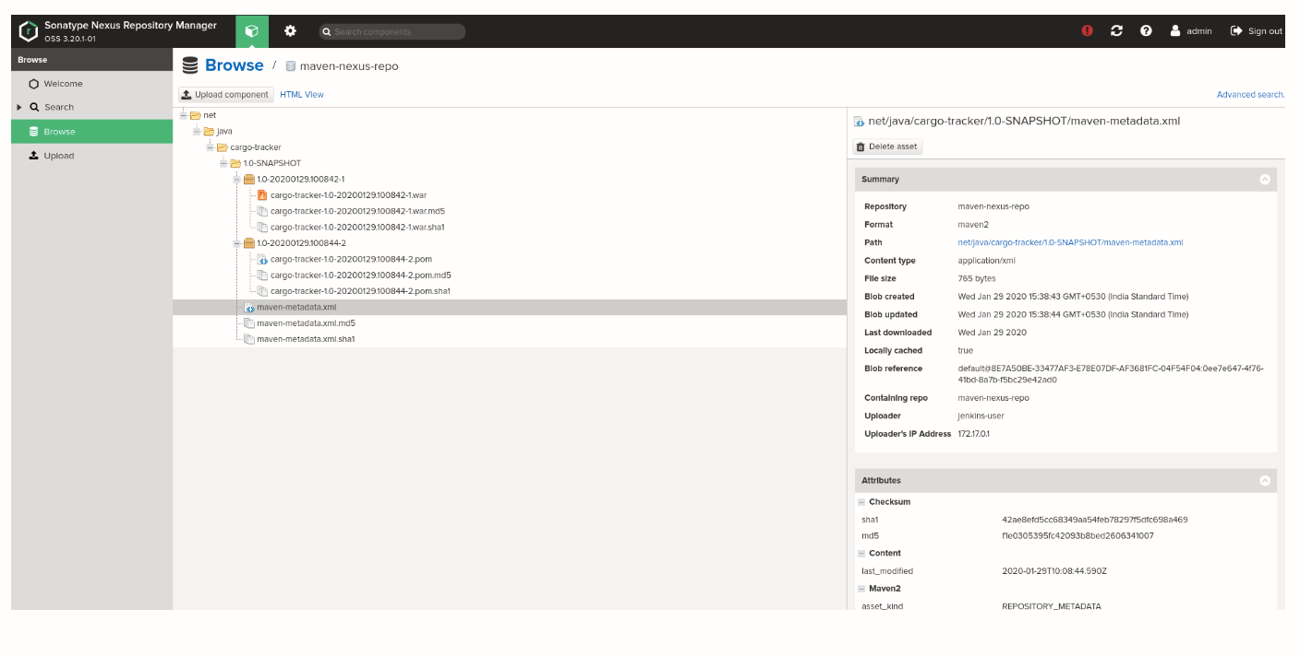

(OR)

# Nexus Integration with Jenkins to Upload/Download Package

This post is pictorial representations of Nexus Integration with Jenkins to Upload/Download Package.

Step 1 – Install Plugins  
Step 2 – Config plugins  
Step 3 – Use Plugins

## Step 1 – Install Plugins

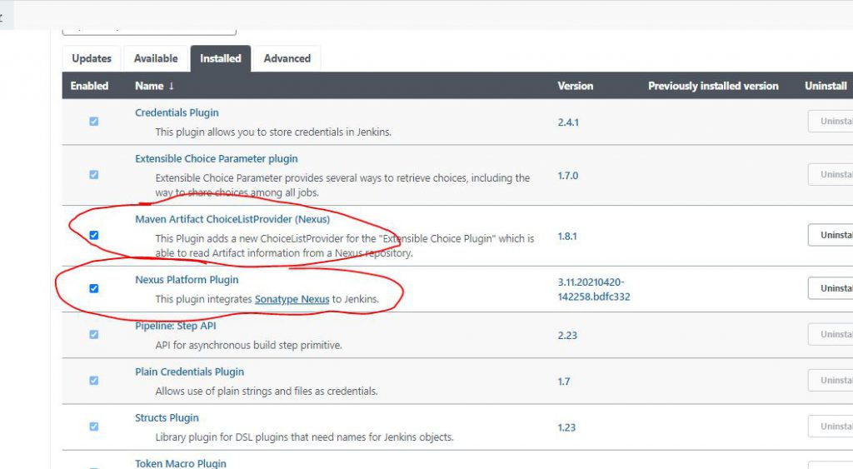

## Step 2 – Config plugin

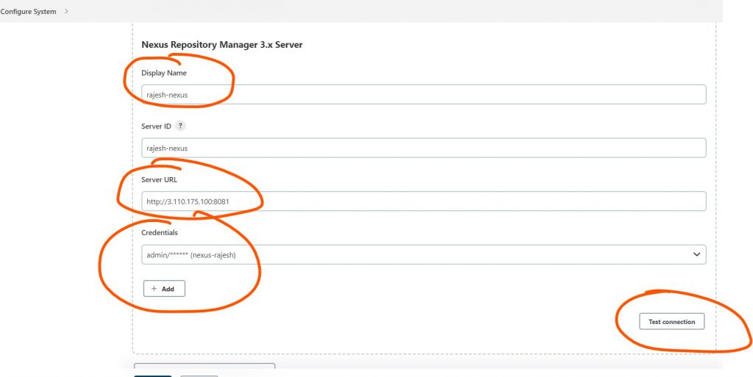

## Step 3 – Use Plugins to Upload Package

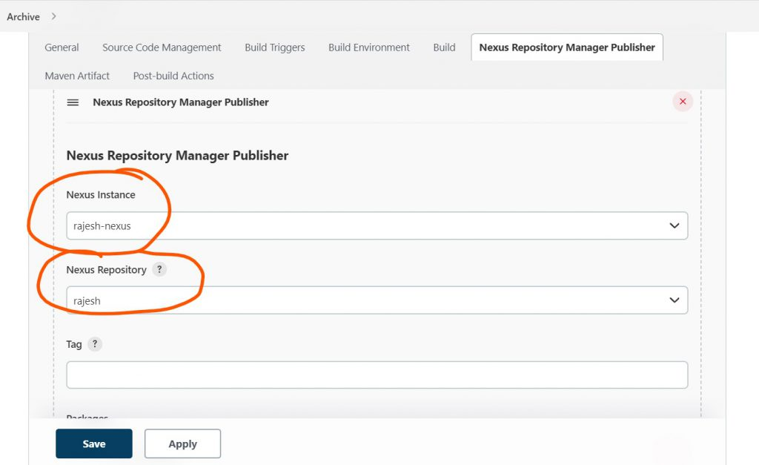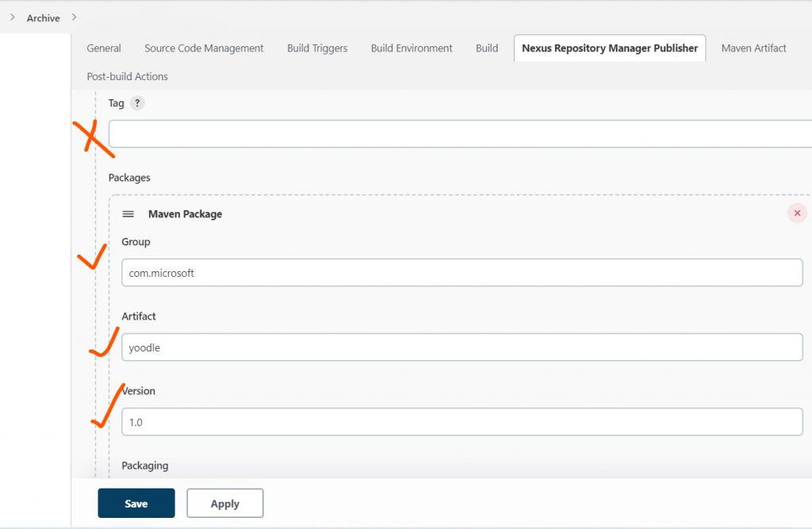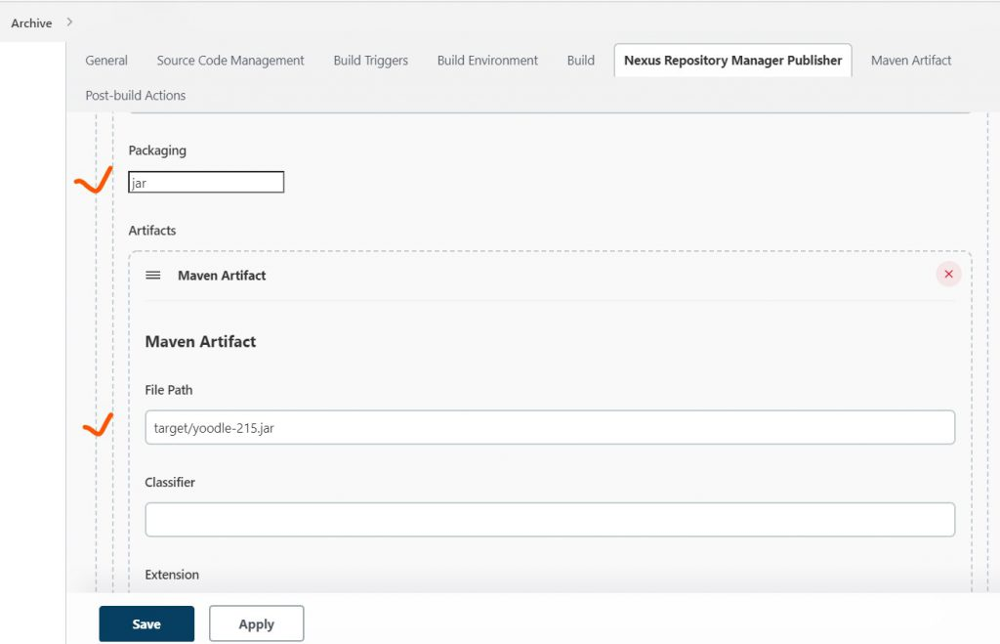

## Step 4 – Download Nexus Package using Jenkins

